# Spring Data Exam – 28 November 2020

# Library Management App

## Functionality Overview

The application should be able to easily **import** hard-formatted data and **support functionality** for also **exporting** the imported data. The application is called – **Library**.

Look at the pictures below to see what must happen:

* Home page before importing anything:



* Import JSON page before importing anything:

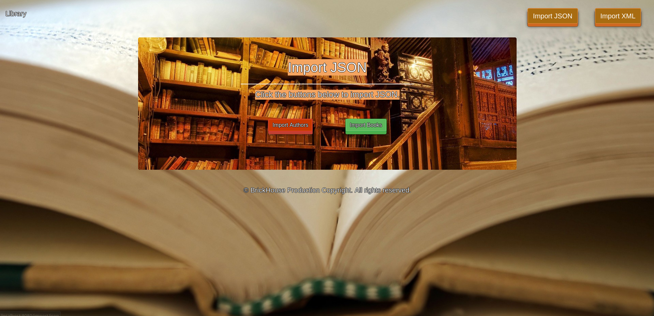

* Import Authors first:

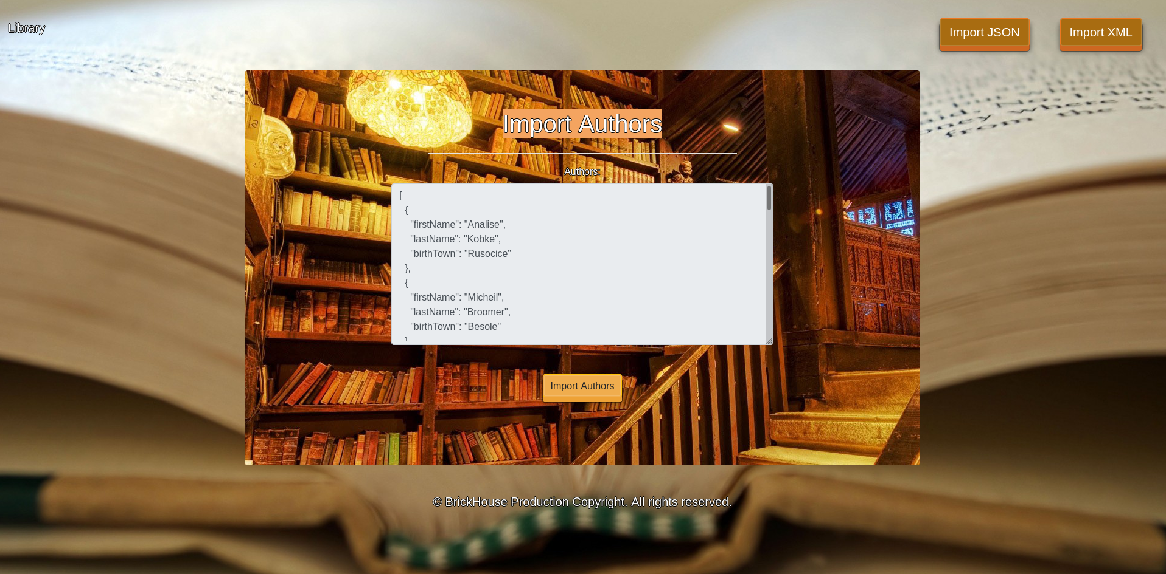

* Import Books second:

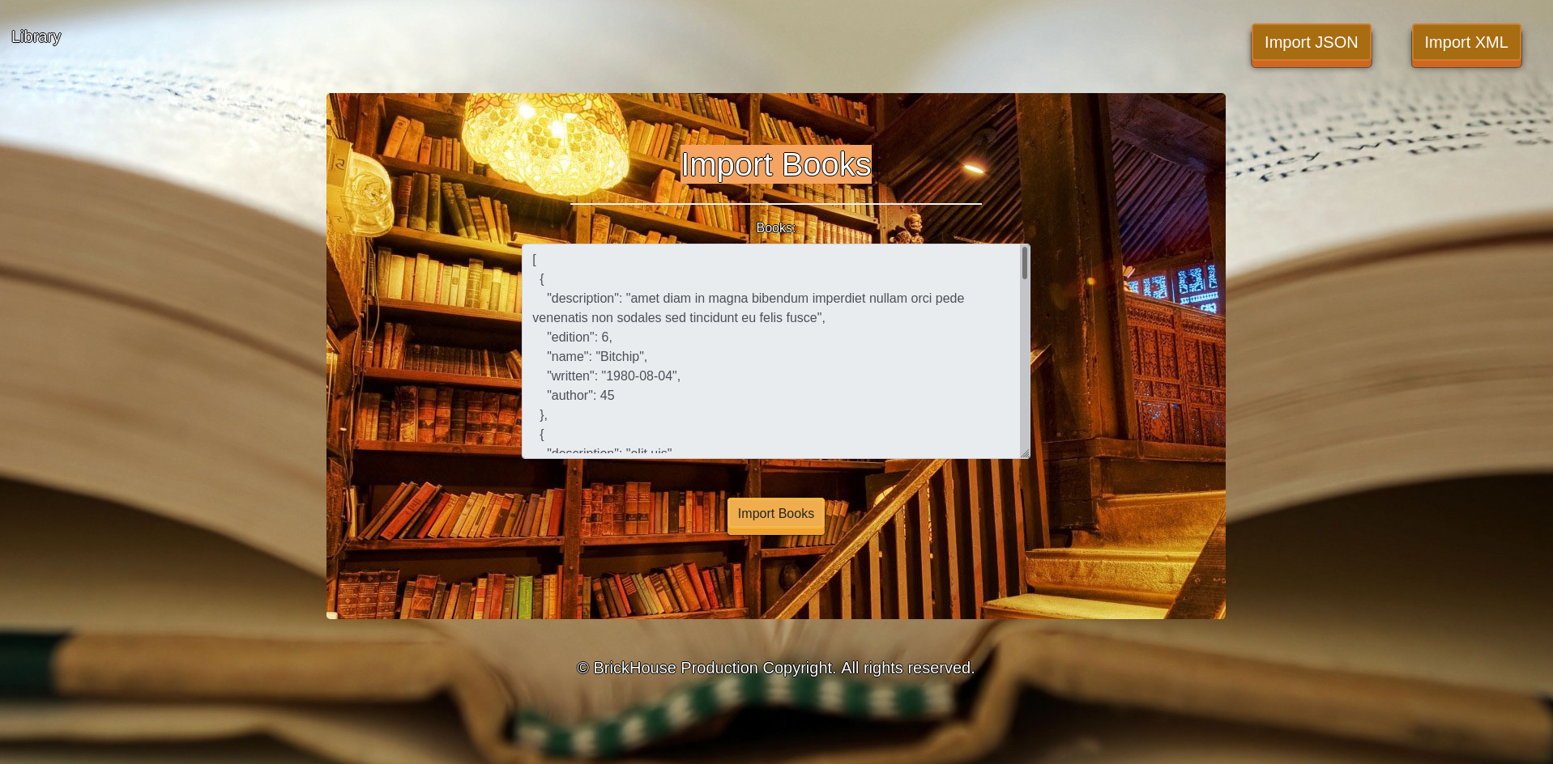

* Import JSON page after importing both files:



* Import XML page before importing the given data:

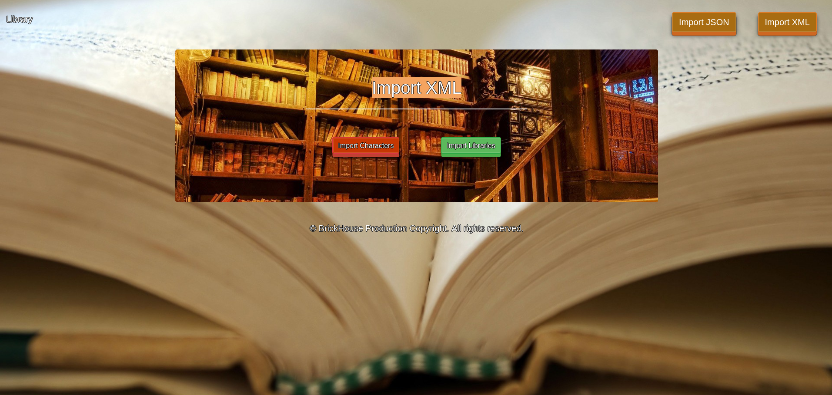

* Import Character data:

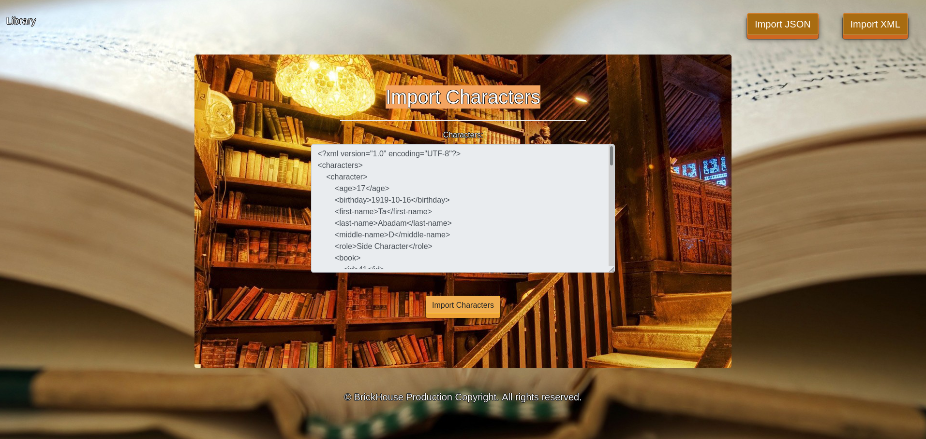

* Import Library data:

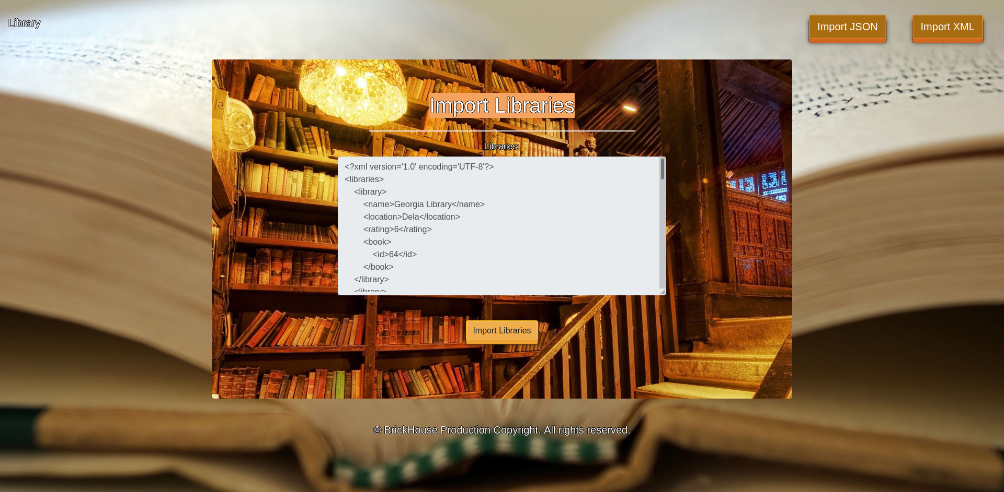

* Import XML page after importing the data:



* Home page after the data is imported:

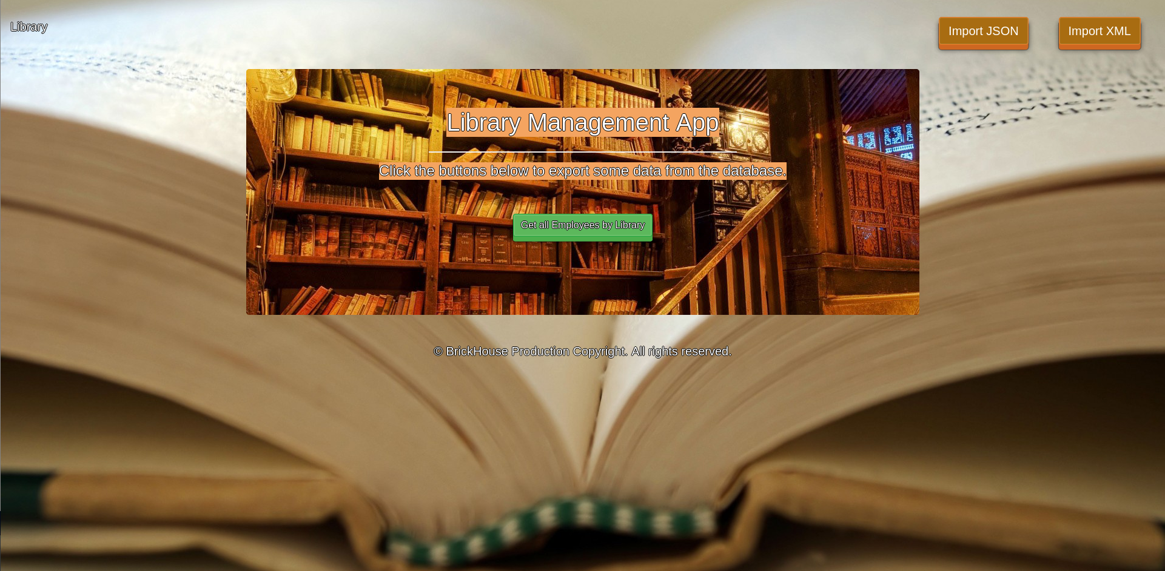

* Export employees by library name descending then by salary:

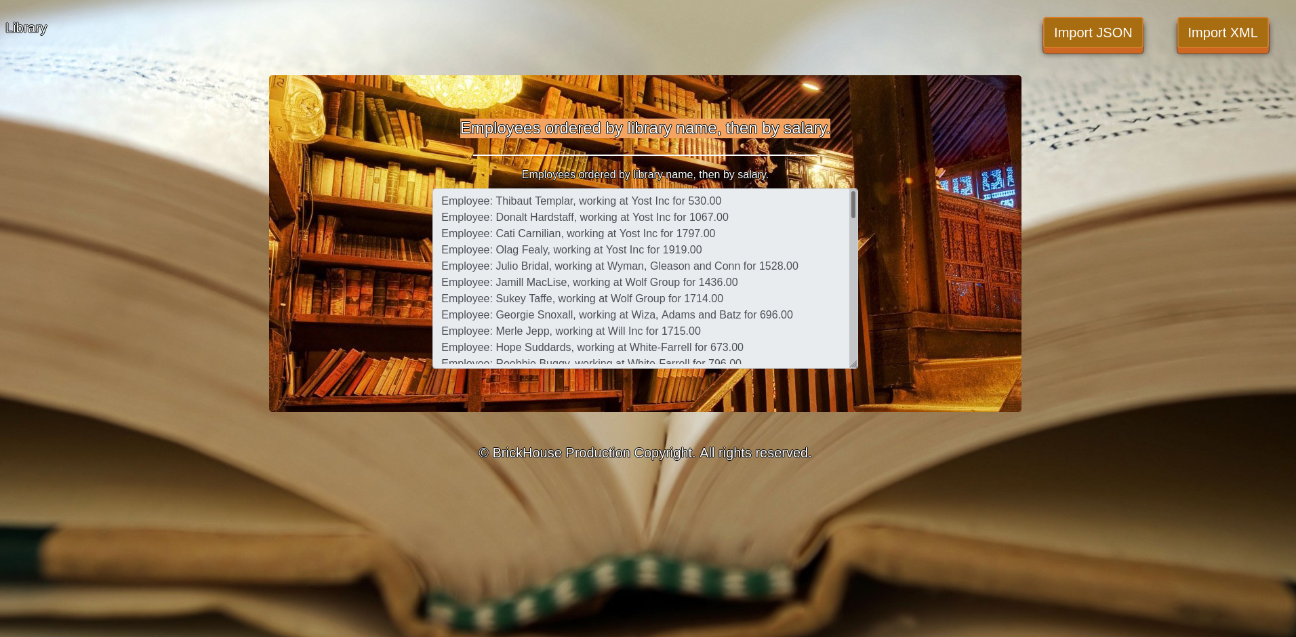

## Project Skeleton Overview

You will be given a **Skeleton**, containing a **certain architecture(MVC)** with **several classes**, some of which – completely empty. The **Skeleton** will include the **files** with which you will **seed** the **database**.

## Model Definition

There are 4 main models that the **Library database** application should contain in its functionality.

Design them in the **most appropriate** way, considering the following **data constraints**:

### Author

* id – **integer** number, **primary identification field**.
* firstName – a **char sequence** Must be at least **2 characters long**. **Cannot** be **null**.
* lastName – a **char sequence**. Must be at least **2 characters long**. **Cannot** be **null**.
* birthTown – a **char sequence** (between 3 to 12 exclusive). **Cannot** be **null**.

The combination of **firstName** and **lastName** makes an author **unique**.

### Book

* id – **integer** number, **primary identification field**.
* name – a **char sequence**. Must be at least **5 characters long**. **Cannot** be **null**.
* edition – a **number** (between **1** and **5** inclusive)
* written – a **date**. Cannot be **null**.
* description – a **very long char sequence.**

### Character

* id – **integer** number, **primary identification field**.
* firstName – a **char sequence.** The first name must be **at least 3 characters long. Cannot** be **null.**
* **middleName –** a **character. Cannot** be **null.**
* lastName – a **char sequence.** The last name must be **at least 3 characters long. Cannot** be **null.**
* **age** – a **positive number**. The character must be **at least** **10 years old** and **no more** than **66 years old**. Cannot be null.
* role – a char sequence. Must be at least 5 characters long. Cannot be null.
* **birthday – A date. Cannot** be **null.**

### Library

* id – **integer** number, **primary identification field**.
* name – a **char sequence**. Must be at least **3 characters long**. The name is **unique**. **Cannot** be **null**.
* location – a **char sequence**. Must be at least **5 characters long**. **Cannot** be **null**.
* reating – a **number** (between **1** and **10** inclusive)**.**

**NOTE**: Name the entities and their class members, **exactly** in the **format stated** above. Do not name them in snake case with the dashes, of course.

#### Relationships

Your partners gave you a little hint about the more complex relationships in the database, so that you can implement it correctly.

One Book may have only one Author, but one Author may have many Books.

One **Character** may be in only one **Book** and one **Book** may have many **Characters**.

One **Book** may be in many **Libraries** and one **Library** may have many **Books.**

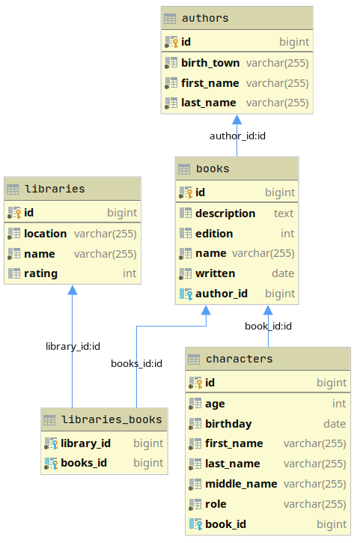

## Data Import

Use the provided files to populate the database with data. Import all the information from those files into the database.

**You are not allowed to modify the provided files.**

**ANY INCORRECT** data should be **ignored** and a message "**Invalid {author / book / library / character }**" should be printed.

When the import is finished

"**Successfully imported {Author/Book/Character/Library} - {(full name) – (birthTown)**

**/ (name) written in (written) / (name) – (address) / (full name) - age: (age)}**"

### JSON Import

#### Authors (authors.json)

|  |
| --- |
| authors.json |
| **[  {  "firstName": "Analise",  "lastName": "Kobke",  "birthTown": "Rusocice"  },  {  "firstName": "Micheil",  "lastName": "Broomer",  "birthTown": "Besole"  },  {  "firstName": "Pier",  "lastName": "Jerams",  "birthTown": "Vale de São Cosme"  },  {  "firstName": "Odella",  "lastName": "S",  "birthTown": "Marne"  },  {  "firstName": "G",  "lastName": "Stubbings",  "birthTown": "Sofia"  },**  . . . |
| **Successfully imported Author: Analise Kobke - Rusocice**  **Successfully imported Author: Micheil Broomer - Besole**  **Invalid Author**  **Invalid Author**  **Invalid Author**  … |

#### Books (books.json)

|  |
| --- |
| **books.json** |
| **[  {  "description": "amet diam in magna bibendum imperdiet nullam orci pede venenatis non sodales sed tincidunt eu felis fusce",  "edition": 6,  "name": "Bitchip",  "written": "1980-08-04",  "author": 45  },  {  "description": "elit uis",  "edition": 1,  "name": "Overhold",  "written": "1973-06-20",  "author": 56  },  {  "description": "nibh quisque id justo sit amet sapien dignissim vestibulum vestibulum ante ipsum primis in faucibus orci luctus et ultrices posuere cubilia curae nulla dapibus dolor vel",  "edition": 2,  "name": "Bi",  "written": "2000-04-29",  "author": 78  },  {  "description": "tellus in sagittis dui vel nisl duis ac nibh fusce lacus purus aliquet at feugiat non pretium quis lectus suspendisse potenti in eleifend quam a odio in hac habitasse platea dictumst maecenas",  "edition": 3,  "name": "Cagtax",  "written": "1989-02-10",  "author": 90  },  {  "description": "sit amet consectetuer adipiscing elit proin risus praesent lectus vestibulum quam sapien varius ut blandit non interdum in ante vestibulum ante ipsum primis in faucibus orci luctus et ultrices posuere cubilia curae",  "edition": 5,  "name": "Keylex",  "written": "1970-09-04",  "author": 34  },**  . . . |
| **Invalid Book**  **Invalid Book**  **Invalid Book**  **Successfully imported Book: Cagtax written in 1989-02-10**  **Successfully imported Book: Keylex written in 1970-09-04**  **…** |

### XML Import

Your new colleagues have prepared some XML data for you to import.

#### Characters (characters.xml)

|  |
| --- |
| **characters.xml** |
| ***<?*xml version="1.0" encoding="UTF-8"*?>* <characters>  <character>  <age>17</age>  <birthday>1919-10-16</birthday>  <first-name>Ta</first-name>  <last-name>Abadam</last-name>  <middle-name>D</middle-name>  <role>Side Character</role>  <book>  <id>41</id>  </book>  </character>  <character>  <age>16</age>  <birthday>1984-04-05</birthday>  <first-name>Nissa</first-name>  <last-name>E</last-name>  <middle-name>Y</middle-name>  <role>Bystander</role>  <book>  <id>65</id>  </book>  </character>  <character>  <age>32</age>  <birthday>1904-08-18</birthday>  <first-name>Bartholomew</first-name>  <last-name>Junes</last-name>  <middle-name>Pоо</middle-name>  <role>Side Character</role>  <book>  <id>126</id>  </book>  </character>  <character>  <age>31</age>  <birthday>1946-01-27</birthday>  <first-name>Merwyn</first-name>  <last-name>Crossan</last-name>  <middle-name>Y</middle-name>  <role>Bys</role>  <book>  <id>77</id>  </book>  </character>  <character>  <age>67</age>  <birthday>1946-01-17</birthday>  <first-name>Brocky</first-name>  <last-name>Pirri</last-name>  <middle-name>O</middle-name>  <role>Main Character</role>  <book>  <id>146</id>  </book>  </character>**  . . .  </characters> |
| **Invalid Character**  **Invalid Character**  **Invalid Character**  **Invalid Character**  **Invalid Character**  **…** |

#### Library (libraries.xml)

|  |
| --- |
| **libraries.xml** |
| ***<?*xml version='1.0' encoding='UTF-8'*?>* <libraries>  <library>  <name>Georgia Library</name>  <location>Dela</location>  <rating>6</rating>  <book>  <id>64</id>  </book>  </library>  <library>  <name>Do</name>  <location>111 Oneill Alley</location>  <rating>8</rating>  <book>  <id>134</id>  </book>  </library>  <library>  <name>Bergnaum, Kuvalis and Upton</name>  <location>736 Pankratz Junction</location>  <rating>55555555555555</rating>  <book>  <id>99</id>  </book>  </library>  <library>  <name>Fisher</name>  <location>3914 Homewood Crossing</location>  <rating></rating>  <book>  <id>38</id>  </book>  </library>  <library>  <name>Dooley-Grimes</name>  <location>6 Nancy Park</location>  <rating>9</rating>  <book>  <id>134</id>  </book>  </library>** |
| **Invalid Library**  **Invalid Library**  **Invalid Library**  **Invalid Library**  **Successfully added Library: Dooley-Grimes - 6 Nancy Park**  **…** |

## Data Export

Get ready to export the data you've imported in the previous task. Here you will have some pretty complex database querying. Export the data in the formats specified below.

#### Export characters by criteria

* Extract **all characters**, who's **age is bigger than or equal** to **32**
* Order them by their **book's name**, then by the **character's last name** in **descending order** and, finally, by the **character's age**.
* Return the information in this format:

**"Character name {full name}, age {age}, in book {book name}**

**…"**

|  |
| --- |
| **Character name Sam Z Zuanazzi, age 59, in book Greenlam**  **Character name Fred Y Yorkston, age 48, in book Kanlam**  **Character name Cesare P Yedall, age 58, in book Kanlam**  **Character name Leonelle T Worling, age 60, in book Asoka**  **Character name Dell K Woolgar, age 62, in book Fix San**  **Character name Isak F Woodwind, age 59, in book Voltsillam**  **Character name Reeba E Woodes, age 61, in book Ronstring**  **Character name Terrence A Wippermann, age 33, in book Home Ing**  **Character name Christan F Wilacot, age 51, in book Greenlam**  **Character name Danni Q Wheildon, age 62, in book Gembucket**  **…** |